Referral agency user guide

Logging in to Clearing House
Check that you are using the correct user name, the format is first name.surname@clearinghouse.org. For example, jane.doe@clearinghouse.org
Password resets can be requested from the CH login page at https://clearinghouse.force.com/login
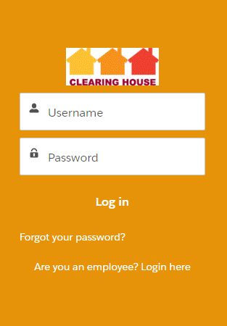
Accounts that have been inactive for 6 months or more are automatically locked. To reactivate a locked account contact the Clearing House Helpdesk by telephone 020 38566008 or email ch@mungos.org

Finding the Clearing House Library
When you log in, you will see a tab for the Clearing House Library. When you click on it the library when open in a new tab.
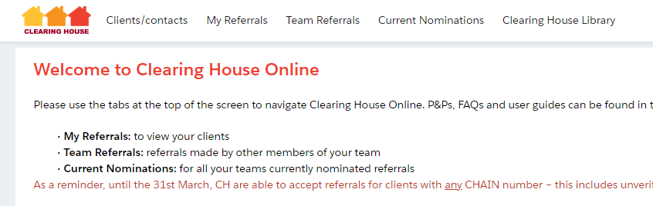

You can also find the Clearing House Library at https://www.mungos.org/our-services/clearing-house/#user_guides​

Returning to the Home Page
Simply click on the Clearing House logo:

Making edits to forms
Any time you would like to edit a form, simply hover over the right hand side of the information you wish to change, where you can see a faint grey icon:

Once you hover over it, it will turn to a darker shade:
You can then click to add/edit the information:
And click ‘Save’ to finish:
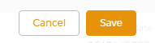
Alternatively, you can simply double click on the information you wish to edit, and you’ll then see the edit box appear:

If you’re searching for someone’s name to select them on a page, please do not click on the New Contact option:
DO NOT USE THIS
A red star means this field is mandatory and you won’t be able to save without having completed it:
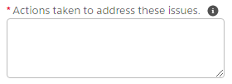
If you see an icon like this on the right - -it will show help text when you hover on it:

If you’re using Chrome as your internet browser and are typing into a text box that you would like to make bigger, you can use the icon in the bottom right to drag the text box to be larger- just click then drag:

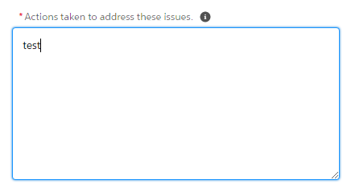
When you need to enter a date, you can either type it in using dd/mm/yyyy format (e.g. 02/10/2022) or use the date picker that appears to select the appropriate date:

Finding a tab
If you ever can’t find a tab referenced in this, you may find it in a tab called More:

Finding a client/adding them to Clearing House and creating a referral
Use the search bar to find a client – you can search by name, CHAIN number or date of birth:

If you are unable to find your client using the ‘Search’ bar, they have not been referred to Clearing House in the past. You will therefore have to create a new client record for them.
Go to the "Clients/Contacts" tab and click "New".
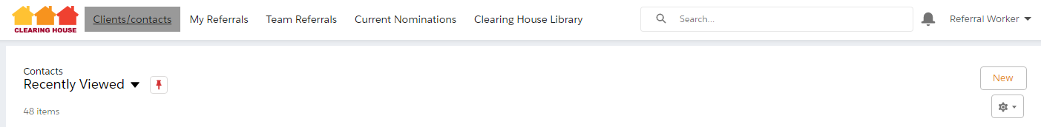

Fill out the information- if the system won’t let you type anything in a section (for instance in Account Name below), these details will be populated automatically by the system, or will be filled out later by Clearing House:
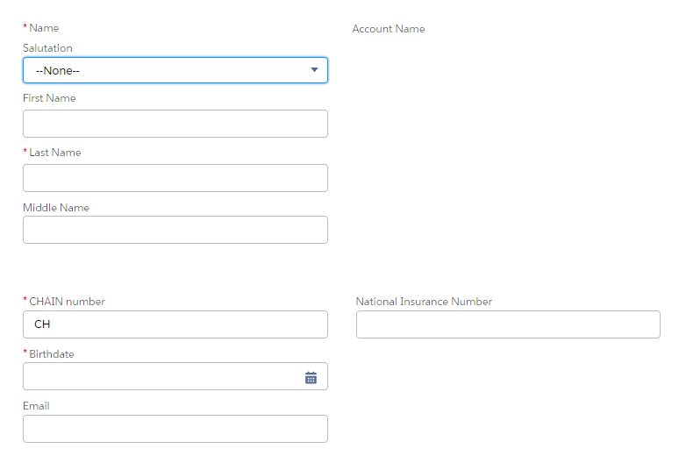
Click Save and you’ll be taken to the client’s record. Now click Create Referral on the top right:
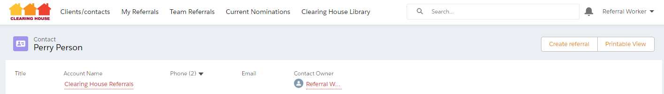
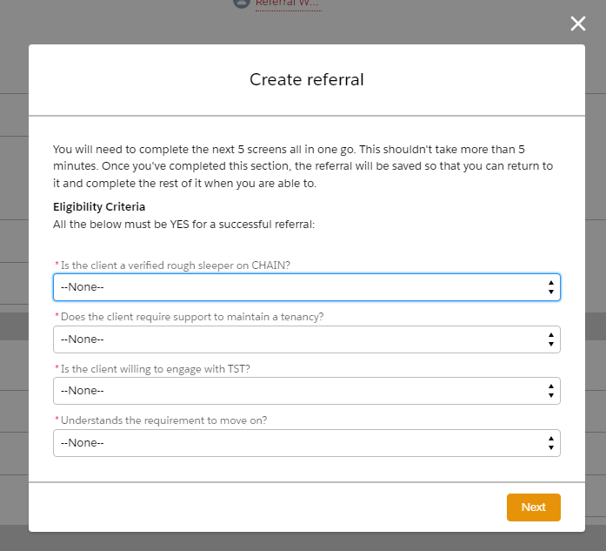
Fill out the details on screen- as the message on screen says, you’ll need to complete 5 screens in one go, but it shouldn’t take longer than 5 minutes:

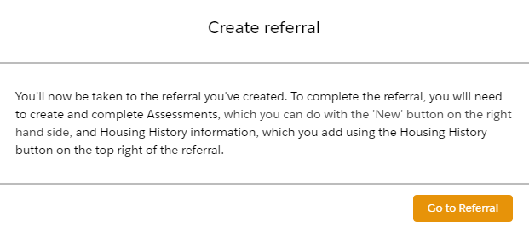
After you’ve filled out all 5 screens, you’ll see this message on screen explaining what you need to do next. The click Go to Referral:

At this point, if you need to go away and back to the referral later, you can do so.
Otherwise, follow the instructions on the right on the referral:
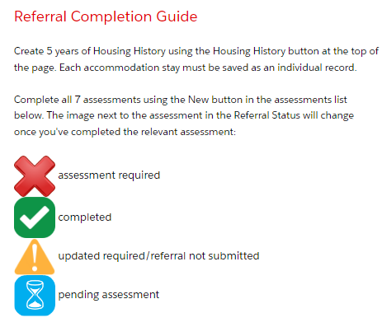
Housing History
Here’s the Housing History button, on the client’s referral on the top right:
You’ll see the housing history appear in the Housing History section once you’ve added a housing history:
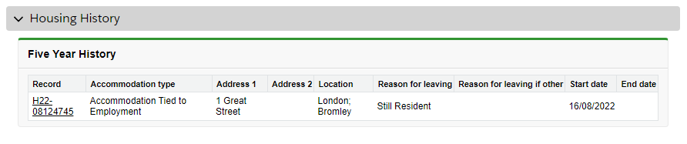
You need to add 5 years’ worth of housing history, with each address being a separate record. Just click the Housing History button as many times as you need. Please provide the best information you have and ensure addresses are recorded in a chronological format. Please don’t leave any gaps, even if it means you have to record an entry with no details – just write something like ‘Unknown address / reason for leaving - client can’t remember’.
If you’ve clicked into the Housing History and want to return to the referral, click on the red link under Referral (RXXXX-XXXXXX):
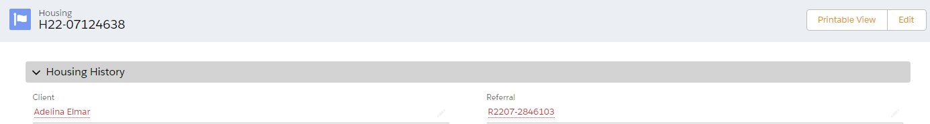
Assessments
On the referral page, here’s where you create the assessments (bottom right of the screenshot):
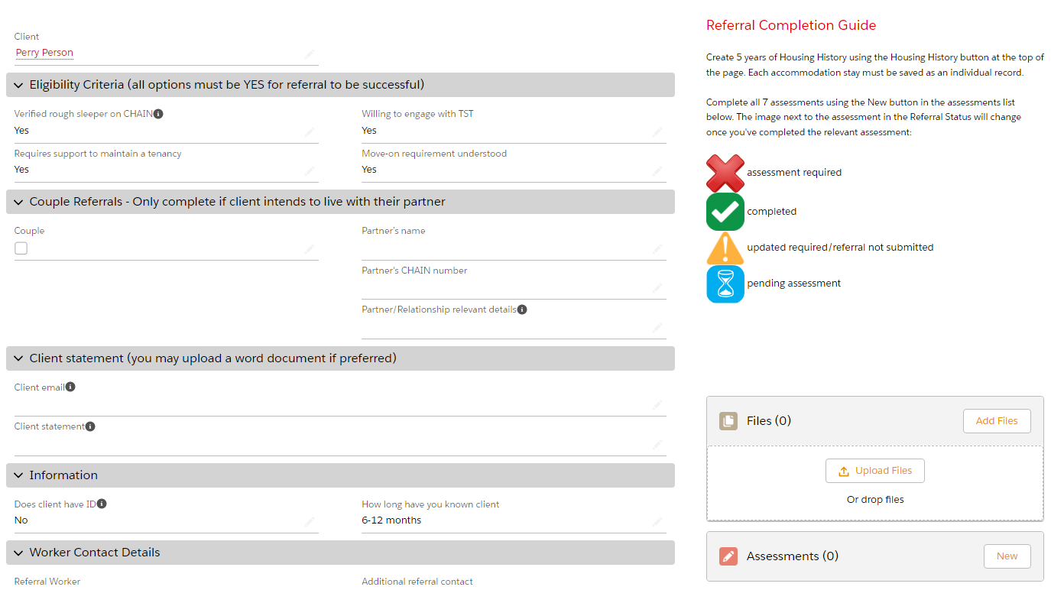
Once you’ve created an assessment you’ll see that its icon in the Referral Status section has changed:

If you need to edit or add extra information to the assessment before you’re ready to submit the referral, click into the red link under the name of the assessment:
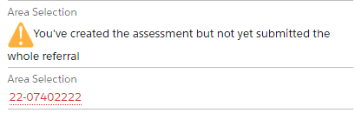
Once you’re on the assessment page, just double click on the answers you wish to update, this will then change to an editable box. Make the changes and click Save.

Client Privacy Notice
Download the privacy notice via the blue link at the bottom of the referral:
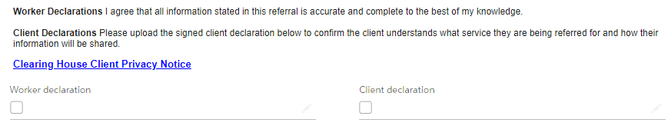
Once the client has signed it, upload the signed client privacy notice in the files section on the right of the screen:
Then click the Worker declaration and Client declaration tickboxes and click Save.
What is the client statement?
Clients are encouraged to write a personal statement expressing why they want to be referred to Clearing House and what they hope to get out of the service. This information is used in the referral assessment process.

Submitting the referral
If you’re ready to submit the referral, click the Submit to Clearing House button on the top of the page:
You’ll either receive a message on screen reminding you of something you haven’t added to the referral yet (e.g. current housing or one of the assessments) or a note that the referral has now been submitted.
Once the Clearing House team have reviewed the referral, you will receive an email advising that the referral has been accepted, not accepted or requesting more information.

Returning to a referral you’ve started earlier
Go to the My Referrals tab. Here you’ll see all Referrals that you are the listed referral worker for. Find the referral and click into it via the link in red that starts with R:
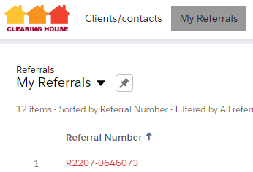
Adding more information to a referral
Login and find the referral (please see the ‘Returning to a referral you’ve started earlier’ section above for guidance).
Click into the assessments you’ve been asked to provide more information on via the links on screen in the Referral Status section:
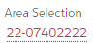
Click the Update button on the top right of the assessment:
Then head back to the Referral via the referral link in the top left of the assessment and find the next thing that needs updating:
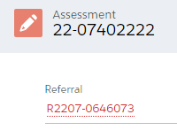
Once you’ve updated everything that needs updating, go back to the Referral and click the Submit to Clearing House button again to resubmit the referral.

Update assessments that are now out of date
If your client is on the waiting list but has not yet been nominated, the assessments may expire.
Login and find the referral (please see the ‘Returning to a referral you’ve started earlier’ section above for guidance).
Click into the assessments you’ve been asked to provide more information on via the links on screen in the Referral Status section:
Click the Update button on the top right of the assessment:
Then click the Submit assessment button, next to the Update button. There is no need to submit the whole referral again.
If you have more than one assessment to update, use the referral link in the top left of the assessment to return to the referral, then find the next thing that needs updating:
Update and submit each assessment that needs updating by repeating the same steps as above.
Printing a summary of the referral
To get a PDF summary of the referral, click the dropdown arrow next to the buttons on the right of the referral, and click Referral Summary.

This will open the PDF in the same window:
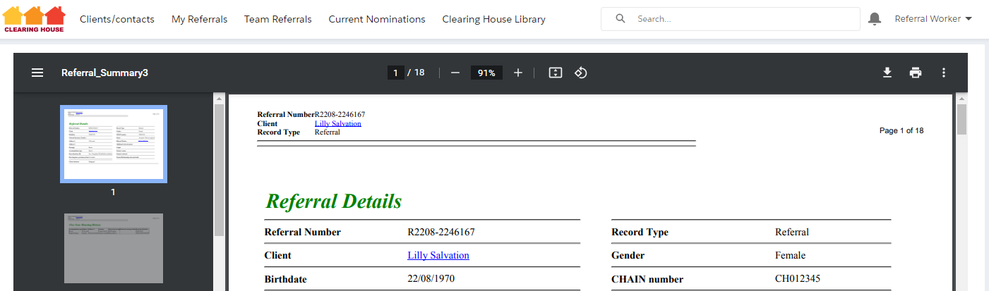
To return to the Referral, click back in your browser window.

